**SPH3U 8.5 Properties of Sound Waves**

1. **Categories of sound waves**

|  |  |
| --- | --- |
| Audible sound waves: |  |
| infrasonic |  |
| ultrasonic |  |

1. **The speed of sound through air**

|  |  |
| --- | --- |
| Equation: |  |

The temperature outside is 23 °C. What is the speed of sound in air at this temperature?

If the speed of sound is measured to be 318 m/s, what is the current air temperature?

1. **Mach number**

|  |  |
| --- | --- |
| Mach number: |  |
| equation |  |

An aircraft is flying at 905 km/h in air at the temperature –50.0 °C. Calculate the Mach number associated with this speed.

1. **Sound intensity**

|  |  |
| --- | --- |
| Sound intensity: |  |
| sound level |  |

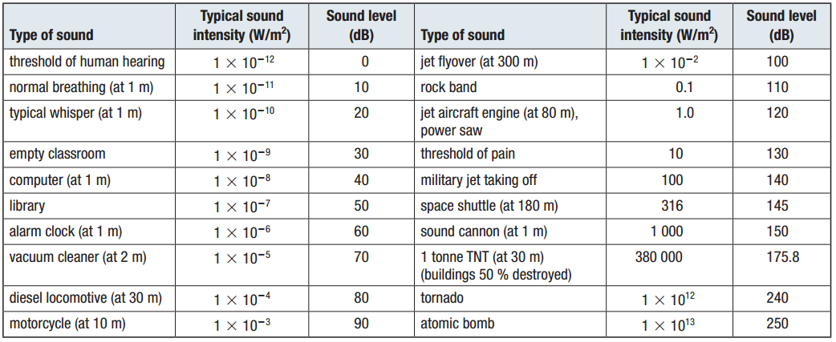

|  |  |
| --- | --- |
| Loudness and distance: | Sound safety: |

**Homework:** page 397 #2-3, 9-10